**3D Print Design Guidelines**

**Tolerances**

0.2 mm creates very tight fitting /have a tight assembly

0.4 - 0.5 mm creates best normal fitting / have free motion

0.3 mm creates some level of tight fitting

**Wall Thickness**

1.4 to 1.6 mm for 4 lines of wall lines, so that in cura we can skip wall infill

0.7 to 0.9 mm produces 2 lines of wall, But always choose mid value

Best Wall Thickness = always multiples of nozzle diameter * 2.

You are doubling the number because you generally print with two shells: one for inside and one for outside.

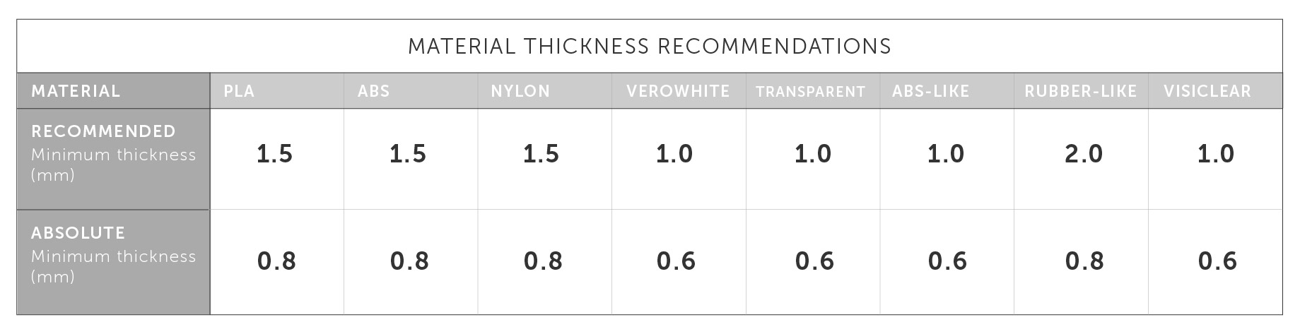

**To Avoid Elephant Foot**

Add Chamfer (0.5mm) to avoid elephant food, always choose chamfer over fillet if design allows.

**Avoid Sharp Corners**

Always add minimum 1mm fillet / chamfer to edges, try to avoid 90 degree sharp corner to improve shape stability and good printing speed.

**To Avoid Support**

Use 45 degree chamfer / fillets to avoid any overhang.

Create sacrificial bridges, using 0.3mm / layer height material beneath the overhang to support the overhang, later remove the sacrificial bridge. Idea here is convert overhangs to bridges using thin bottom layer for overhang. Later it get removed.

**Maximum overhang length**

If you design a part that includes an unsupported 90° overhang, then the maximum overhang length you will be able to print without using support will be between 1mm and 2mm.

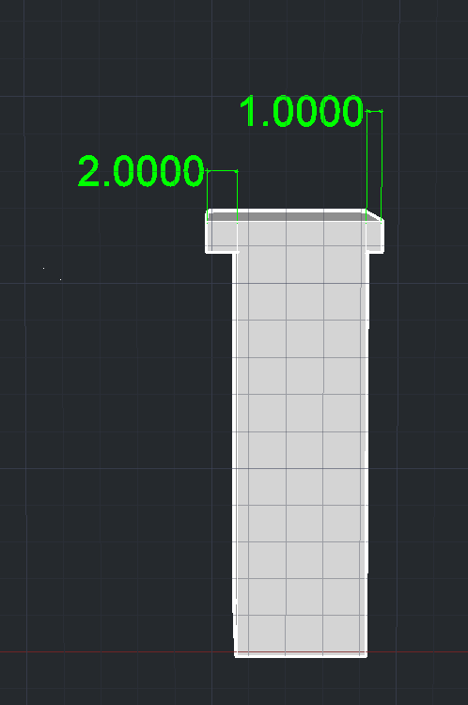The maximum length for unsupported overhangs falls between 1-2mm

**Maximum unsupported overhang angle**

How much of your model can you print at an angle without using support? This constraint is material dependent. With PLA and cooling fans, you should be able to print parts with angles up to 55°. However, as a rule, you will generally be able to print unsupported parts successfully for any angle up to 45°.

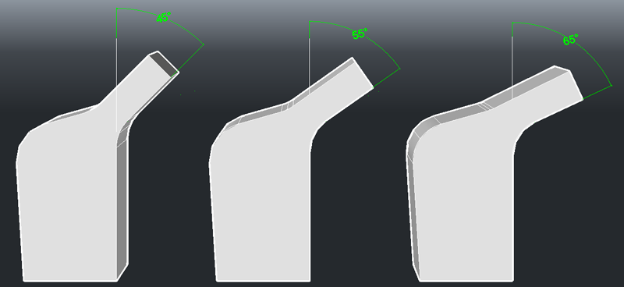

The first model will print without support, the second might, but the last one needs support

**Maximum horizontal span/bridge**

This property is mostly affected by the quality of the material you're printing with and how close the bridge is to the heated bed. Generally you will want to slow the print speed down and reduce the temperature to achieve bridging. You should be able to achieve a bridge of about 25mm across if you enable active cooling.

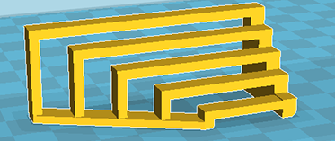Bridge

**Minimum embossed detail**

0.5mm is universally readable from a distance, while 0.2mm is visible on close examination. As a rule of thumb the embossed details should be no less than your Wall Thickness setting.  
  
 **Minimum engraved detail**

Engraved details are similar to embossed details, except that they are more likely to produce fluctuations in the model wall about 5mm-10mm away from the feature in the direction that the extruder is traveling in. The imperfections are usually attributed to loose belts, or too high a print speed.

**Minimum Hole Diameter**

While this is somewhat dependent on material and settings, a safe assumption is that the diameters of your holes need to be at least twice the value of your Line Width setting.

**Minimum allowance**  
 When connecting parts together you have two basic options:

* Press Fit, Force-Fit or Interference-Fit occurs when parts are held together by friction.
* Sliding Fit or Free-Fit occurs when the connection between parts allows for movement.

Every company’s 3D printer is slightly different and you will have to test your printer and settings to determine your tolerances. Generally if you are designing a 3D printed press-fit part, allow for a 0.2mm offset from the interior feature. You may want to go as small as 0.1mm on each side, but once you’ve connected a part with an allowance of less than 0.2mm you will not be able to remove that part without breaking the model. The minimum allowance for a moving or rotating part is 0.4mm on each side. Basically you are separating your parts by a wall thickness. For gears and other complex intermeshing parts, use a 0.5mm offset to make up for any errors in X-Y accuracy.

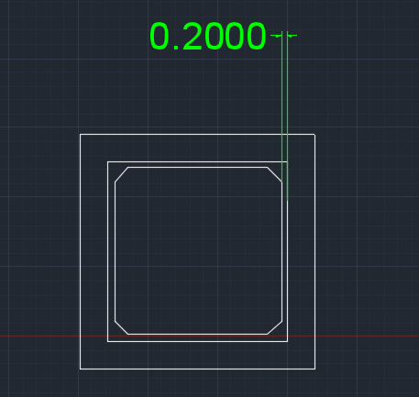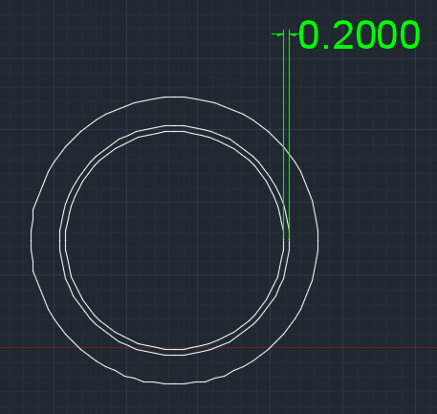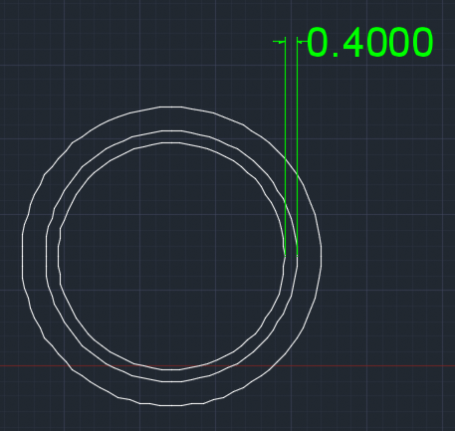

Press fit with Press fit Sliding fit

chamfered edges for

better fit